

Koo Wee Rup – Longwarry Flood Protection District

Customer Service Charter

August 2024

Table of contents

Introduction 4

About the Koo Wee Rup – Longwarry Flood Protection District 4

History of the District - Drainage and Flooding 5

About the Charter 5

Term of this charter 6

Our role 7

Our role in waterway and drainage management 7

Our role in the District 8

Precept Rate & Waterways and Drainage Charge 8

Waterway and catchment health 9

Flood protection and drainage services 11

Flooding 11

Development Planning 11

Flood protection levels of service 12

Maintenance levels of service 13

Maintenance projects 15

Maintenance works prioritisation 15

Factors impacting our level of service 16

Renewal Projects 17

Rights and responsibilities 17

Landowner responsibilities 18

Local councils’ responsibility 20

Enquiries, information, consultation and privacy 21

How to make an enquiry or find more information 21

By phone 21

In writing 21

Online 21

Interpreter and TTY services 21

Consulting with our customers 1

Koo Wee Rup – Longwarry Advisory Committee 1

Specific projects 1

Privacy 2

Requests, complaints and dispute resolution 3

How to make a request for unplanned works 3

Notifications 3

Dispute resolution 3

Making a complaint 3

Reviewing complaints and disputes 4

Seeking external resolution of disputes 5

Response times 5

Reporting on our performance 7

Assessing our performance 7

Corporate level reporting 7

Specific reporting for precept ratepayers 7

Proposed annual works program 7

Definitions 8

Operating context 10

Our regulation 10

Our Waterways program 10

# Introduction

## About the Koo Wee Rup – Longwarry Flood Protection District

In the Koo Wee Rup – Longwarry Flood Protection District, drainage is essential to the way of life.

Alongside Traditional Owners, residents, local councils, and other authorities, Melbourne Water is the caretaker of waterway and catchment health and manages the unique drainage network that helps to reduce flood risk in the area – keeping the region viable as an important agricultural area.

To fund this higher level of drainage service, property owners in the District pay a special precept charge through their South East Water bill.

The District is also an area of high conservation value as it provides wildlife corridors and habitat for nationally significant threatened and endangered species and ecological communities such as the Southern Brown Bandicoot and Subtropical and Temperate Coastal Saltmarsh.

We balance this important conservation work with the need to maintain the drains and are always looking for ways for beneficial outcomes for both.

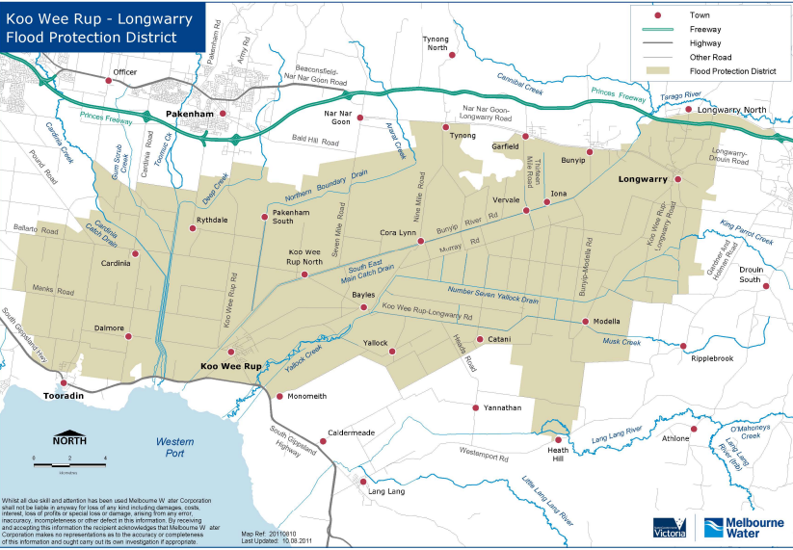

*Figure 1: Map of the Koo Wee Rup – Longwarry Flood Protection District*

## History of the District - Drainage and Flooding

The Bunurong people of the Kulin Nation are the traditional custodians of the land on which the Koo Wee Rup–Longwarry Flood Protection District is now located.

Prior to European settlement, the area was part of the Koo Wee Rup Swamp (or Great Swamp), an extensive wetlands ecosystem encompassing more than 40,000 hectares of dense swamp from Tooradin to Bunyip.

The swamp was fed by a 2,208 square kilometre catchment that included the three major drainage basins of Cardinia Creek, Bunyip River, and Lang Lang River catchments. The Yallock Creek formed the only permanent outlet from the swamp into Western Port Bay.

In the late 1800’s, the swamp was slowly drained with a network of constructed channels and improved outfalls to Western Port Bay. This early drainage system allowed limited agricultural activities within the reclaimed swamp between floods, and passage through the swamp to Gippsland.

Today, the drainage system that includes the two main carrier drains (the Cardinia Outfall Drain and the Bunyip Main Drain) provides a relatively high level of flood protection for a rural area and allows intensive agricultural activities and associated development.

The District has flooded many times. The largest flood on record (approximately a 0.5-0.7 per cent Annual Exceedance Probability (AEP) event) occurred in 1934, when the entire District was inundated and more than 1,000 people became temporarily homeless. AEP is the likelihood of the occurrence of a flood of a given size happening in any one year.

Following the 1934 flood and subsequent regular flooding of the District, construction of the Yallock Outfall Drain commenced in the 1950s. The outfall splits the flow of the Bunyip Main Drain at Cora Lynn. The resultant decrease in flows in the Bunyip Main Drain reduces the frequency of overtopping the drain levees and thereby provides flood mitigation benefits to the Koo Wee Rup township. Flooding in the District results from not only the overtopping of drain levees but also occurs when floodwaters from the local catchments exceed the capacity of the local drainage system.

Due to the extremely flat terrain of the District, even relatively minor floods can inundate large areas. The flat terrain results in slow water movement and, when flooding occurs, it can last for a number of days or even weeks.

## About the Charter

We understand that working together with our partners, stakeholders and customers is essential to what we do. That is why we are constantly striving to improve our relationships with, and services provided to, our customers in the District.

This Customer Service Charter (the ‘Charter’) is for the precept ratepayers in the Koo Wee Rup – Longwarry Flood Protection District who receive flood protection and drainage services from Melbourne Water. This is a fee for service to manage drainage across the District.

This charter outlines:

* your rights and obligations as a user of our flood protection and drainage services
* the minimum standards of service that you can expect
* key information about the District and drainage system
* the Precept Rate and what it entails
* how you can give us feedback on any aspect of our service.

## Term of this charter

This charter covers the remainder of the statutory period of Melbourne Water’s Pricing Submission for 2021 to 2026.

# Our role

Robust and productive relationships with our customers and stakeholders are essential to our continued success.

## Our role in waterway and drainage management

Melbourne Water is the designated caretaker of waterway health for the Port Phillip and Westernport region, and the regional drainage and floodplain management authority.

We work on behalf of, and in close collaboration with, the people of Melbourne and surrounds. Our responsibilities include the management of more than 25,000 kilometres of rivers and creeks across the region, as well as estuaries, wetlands, and floodplain. We also manage the regional drainage system including drains, levees, channels, and retarding basins that carry flows and reduce flooding impacts.

Our Waterways and Drainage Program includes actions designed to improve the health, quality, amenity and understanding of our waterways. This in turn helps us manage environmental flows and water quality, reduce flood risk for communities, support sustainable development, and involve and engage our customers.

Our activities include:

* managing and monitoring rivers, creeks, and wetlands.
* managing the regional drainage system.
* providing a safe level of flood protection.
* working with community groups to improve river health.
* managing river diversions.
* regulating works on rivers and creeks.
* cleaning up non-hazardous pollution spills in waterways and Melbourne Water managed drains.
* ensuring urban development is safe and meets flood and environment standards.

Under the Water Act (1989), Melbourne Water has responsibility for the bed and banks of the waterway, as well as managing the area of land immediately adjacent to the waterway. In addition to the precept rate funded works (*outlined in more detail later in the Charter*), Melbourne Water undertakes works driven by the Flood Management Strategy, Healthy Waterways Strategy, and urban development within the precept area.

Melbourne Water works closely with local councils and other authorities in carrying out its role.

Local councils are the local planning authority responsible for local drains, road networks, and street and property drainage that feed into the regional drains, rivers, and creeks.

VicRoads is responsible for drainage along highways and major roads.

*Connections into Melbourne Water controlled drains and waterways require Melbourne Water approval.*

## Our role in the District

Melbourne Water manages and maintains two types of drains on behalf of the community within the District – precept drains and carrier drains.

* A precept drain originates within the flood protection district and drains the local area.
* 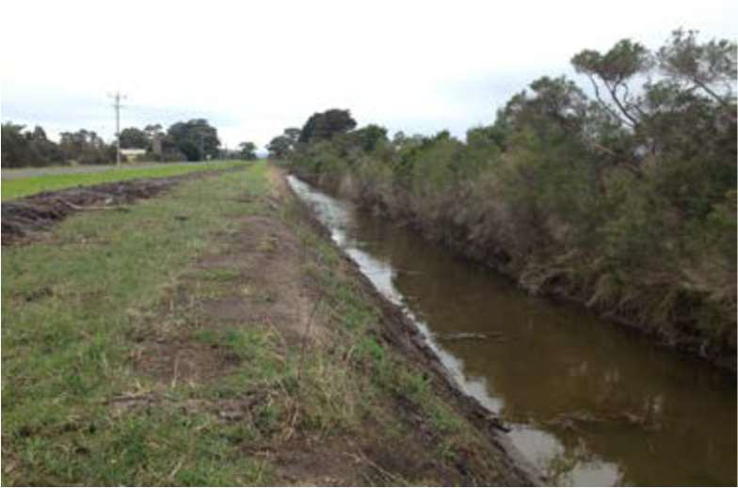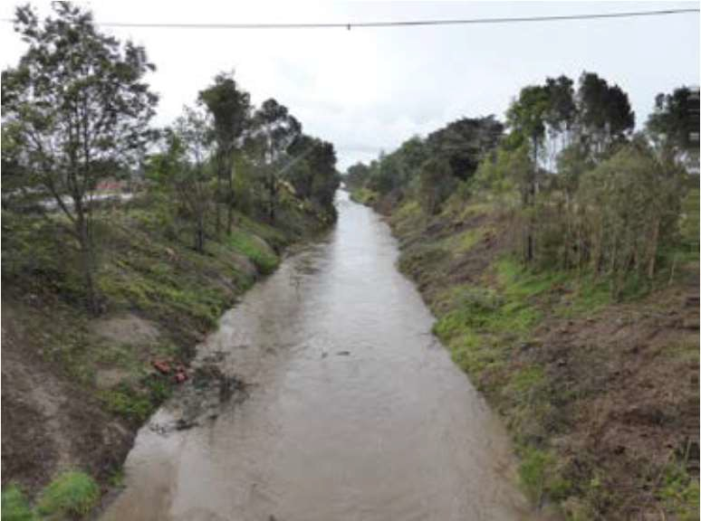A carrier drain originates outside the precept area, taking water from the precept drains and carrying it through the area to Westernport.

*Figure 2: Bunyip Main Carrier Drain* *Figure 3: Dalmore Road Precept Drain*

In addition to maintaining local carrier and precept drains, we also maintain culverts, floodgate structures, bridges, fences, and flood warning systems in the area to provide an increased level of drainage and flood protection.

## Precept Rate & Waterways and Drainage Charge

To help us maintain this drainage network and provide vital flood protection to this flood-prone area, we charge an annual Precept Rate to ratepayers in the Koo Wee Rup – Longwarry Flood Protection District.

Works on precept drains are entirely covered by the Precept Rate and works on carrier drains are part funded by this rate and part funded through Melbourne Water’s annual Waterways and Drainage Charge.

The Waterways and Drainage Charge helps us run projects that protect and improve the health of our rivers and creeks and provides regional drainage services such as those provided in the Koo Wee Rup – Longwarry Flood Protection District. However, given that ratepayers in this area are already paying the Precept Rate, they are exempt from paying the Waterways and Drainage Charge.

## Waterway and catchment health

Koo Wee Rup Longwarry Flood Protection District is an area of high conservation value as it provides wildlife corridors and habitat for threatened and endangered species and ecological communities.

Like all authorities, Melbourne Water must comply with relevant State and Commonwealth legislation when undertaking its works. Some of the key protected species and communities found in the area are: Southern Brown Bandicoot, Growling Grass Frog, Australian Grayling, Dwarf Galaxias and the Subtropical and Temperate Coastal Saltmarsh. 

*Figure 4: Southern Brown Bandicoot*

We have implemented a number of measures to ensure the Environmental Protection and Biodiversity Conservation Act (EPBC) listed species, ecological communities and other matters of national environmental significance are protected whilst we carry out our necessary drainage works as quickly as possible.

We have worked through the EPBC Act requirements with the previous Department of Climate Change, Energy, the Environment, and Water (DCCEEW) and DEECA (Department of Energy, Environment and Climate Action) to gain an exemption under the EPBC Act to proceed with the annual routine maintenance works without the need to seek further approval.

Melbourne Water has developed an operational document, *Asset Management Procedure for Koo Wee Rup Longwarry Flood Protection District CORP AM P046*, which outlines our exemption to the requirement for referrals under the EPBC Act to conduct routine maintenance works across the entire District.

Routine maintenance is defined as ‘the maintenance of existing utility assets within the identified asset maintenance zones.’

Activities outside routine maintenance works may still need to be referred which could include:

* capital improvement/renewal works.
* new or relocated infrastructure.
* expansion of maintenance footprint.

For these activities, our aim is to minimise negative impacts on the EPBC listed species, ecological communities, and other matters of national significance by:

* carrying out desktop studies, field surveys and consultation with state and federal environment agencies and local experts to identify the areas where our works may affect EPBC listed species.
* working with the relevant agencies to ensure necessary works are undertaken in a way that minimises impacts.
* ensuring we have detailed field surveys and investigations completed so our works and mitigation measures meet regulators’ requirements.

We are committed to protecting areas of high conservation value whilst carrying out our essential works in the area, with minimal disturbance to the environment and the communities we serve.

# Flood protection and drainage services

Providing a cost-effective level of service that meets or exceeds our customers’ expectations.

We are committed to delivering an accessible and responsive service to our customers in the Koo Wee Rup – Longwarry Flood Protection District. This is divided between two service standards – Flood Protection Levels of Service and Maintenance Levels of Service.

This elevated level of service is directly related to the level of funding we receive via the Precept Rate.

## Flooding

Flooding is a natural and inevitable part of our weather cycle.

Most floods take hours or even days to develop, giving residents time to prepare or evacuate. Other floods generate quickly and with little warning. So-called [flash floods can be extremely dangerous](https://www.nationalgeographic.com/environment/article/flood-safety-tips), instantly turning a babbling creek into rushing rapids that sweep everything in their path downstream.

While flooding can result in damage to homes, businesses, critical infrastructure, and farming (including livestock and crops), it can also have a positive effect on our natural environment. Flood events can replenish wetlands, groundwater, and ecosystems, as well as disperse valuable nutrients.

Melbourne’s waterways and drainage system copes well with most storms, however there are some storms of such intensity that not all storm water can be re-directed through the system to rivers, creeks and drains, resulting in flooding.

## Development Planning

Melbourne Water has prepared *Guidelines for Development within the Koo Wee Rup – Longwarry Flood Protection District* (July 2019) to set out specific requirements that apply to development proposals in the District and surrounding flood-prone areas.

The aim of Melbourne Water’s guidelines is to ensure that proposed subdivision and development is compatible with any flood risk and takes into consideration the unique flooding nature and history of the District.

These guidelines can be accessed here:

<https://www.melbournewater.com.au/media/586/download>

The guidelines supplement the state-wide *Guidelines for Development in Flood Affected Areas* (2019) prepared by the Department of Environment, Land, Water and Planning (DELWP, now Department of Environment, Energy and Climate Action).

## Flood protection levels of service

Previous assessments indicate that most drains in the Koo Wee Rup – Longwarry Flood Protection District have somewhere between a 1 in 2 and 1 in 7-year Annual Recurrence Interval (ARI). This equates to around a 15 to 40% chance of flooding occurring outside of the channel in any one year. Revisions in flood modelling guidelines and updates to flood mapping technologies has improved how best practice flood mapping and associated levels of service are calculated. Melbourne Water are reviewing the validity and currency of past drainage assessments in the context of the improved technology.

Recent investigations and studies indicate that in some areas, the capacity exceeds that of the 1 in 2 year and 1 in 7-year Annual Recurrence Interval (ARI) events. The key focus of the maintenance program is optimising the flood level of service across the program based on the design intent of the drain. For example, ensuring drains such as the Dalmore Road Drain is operating as it was designed rather than waiting until sediment and vegetation reduce the capacity to only a 1 in 2-year capacity.

Following the completion of the modelling program (anticipated in 2026) the intention is to define the level of service based on the most up to date information.

The following table summarises our key service standards in Flood Protection Levels of Service:

|  |  |
| --- | --- |
| **Service component Level of service** | |
| **Flood protection levels of service** | |
| **Main carrier drains** | The main carrier drains tended to be constructed to two different sizes:   * 1 in 7-year Annual Recurrence Interval (ARI) event* or * 1 in 15 year Annual Recurrence Interval (ARI) event*   This equates to about a 15% and 7% chance respectively of flooding outside the channel in any one year.  \**Under review pending outcomes of upcoming flood mapping* |
| **Local precept drains** | 1 in 2 year Annual Recurrence Interval (ARI) event*  This equates to about a 40% chance of flooding outside the channel in any one year.  \**Under review pending outcomes of upcoming flood mapping* |
| **Flood warning alarms** | Melbourne Water operates and maintains an extensive hydrometric monitoring system for collection of rainfall and water level data in the District.  Flood watches are developed in consultation with the Bureau of Meteorology (BoM) based on predicted rainfall and catchment conditions. Flood Warnings are developed by Melbourne Water and issued by the BoM for the Bunyip River at Iona and Cora Lynn.  Melbourne Water manages flood events by activating its Flood Response Plan. |
| **Strategic flood mapping**  **/** **mitigation** | Undertake floor level related flood mapping. This information is used in the flood risk asset framework. Depending on the assessed risk, potential mitigation options may be explored. |

## Maintenance levels of service

Providing a cost-effective maintenance level of service that meets or exceeds our customers’ expectations.

Each year we invest $1.2 million in our annual maintenance program for the area, which includes:

* de-silting
* vegetation control
* erosion control
* bridge and structures maintenance
* debris removal
* repairs.

Our primary consideration in preparing the annual maintenance program is to maintain the drainage and flood protection function of the precept and carrier drains.

Over the past five years, our maintenance program has delivered works across the following categories:

*Figure 4: Breakdown of the typical spend of the Precept Rate charge*

The following table summarises our key service standards in Maintenance Levels of Service:

|  |  |
| --- | --- |
| **Level of service** | **Key service standards** |
| **Drain de-silting** | Prioritisation for de-silting work is considered using a risk-based approach that considers the likelihood of flooding, the consequence of flooding and the benefit of intervention. |
| **Weed control** | Weed control and vegetation management is undertaken to reduce the risk of drain blockage due to vegetation.  Frequency is dependent on criticality of drain and is typically annually. |
| **Floodgate inspections** | Missing or damaged floodgates and structures are repaired through the annual works program.  Inspected and maintained based on a risk-based program. |
| **Levee banks** | Damaged levee banks are repaired through the annual works program.  Inspected annually for routine maintenance. |
| **Bridge inspections – major roads (and over carrier drains)** | Major Road bridges are inspected following significant rain events.  Debris threatening the bridge's structural integrity or hydraulic function of the carrier drain will be removed when safe after rain events. |
| **Bridge inspections – minor roads and property access** | There are hundreds of minor road bridges across the District. The maintenance of which lies with the asset owner.  The performance of the network is inspected following major rainfall events. |
| **Debris removal – rubbish and minor debris** | Removed in line with scheduled works program or where debris is threatening the hydraulic function of the drain. |
| **Maintenance tracks to drains** | All-weather access to Melbourne Water drains will be maintained. |
| **Grass cutting** | Grass in mowable drains and Melbourne Water’s easements will generally be cut twice a year. |
| *\* These service levels are based on the annual budget in consultation with the Koo Wee Rup – Longwarry Advisory Committee.* | |

Melbourne Water carries out both asset renewal and routine maintenance projects in the District as part of its annual maintenance program.

## Maintenance projects

Maintenance projects are divided into two categories: planned work and unplanned work.

* Planned work is routine or planned maintenance that Melbourne Water has prioritised to be undertaken throughout the year.
* Unplanned work is emergency or unexpected maintenance or repair work that:
  + Is required following unusual or extreme weather events.
  + Is requested to be undertaken by a precept ratepayer or the Advisory Committee.
  + Melbourne Water will accept requests to consider undertaking unscheduled work that is identified by landowners and compare priorities against the existing program.

## Maintenance works prioritisation

Whilst the annual maintenance program budget of $1.2 million is significant, it does not allow us to maintain every drain in the District every year. Therefore, we need to continually prioritise our works to mitigate the risks associated with flooding by targeting the highest risk locations.

We consider the following factors in prioritising planned and unplanned works:

* protecting public safety.
* protecting community assets in townships.
* helping support private properties and agricultural viability,
* impact on public amenity.
* protecting key biodiversity values within and along the drainage network.
* impact on water quality.

## Factors impacting our level of service

The level of service we provide in Koo Wee Rup – Longwarry may occasionally be affected by factors outside of our control, such as:

* climatic conditions including (but not limited to):
  + unusual or extreme weather events such as total fire ban days, high winds or flood events that pose a safety risk to our workers, contractors, and customers.
  + impacts of extreme weather systems such as La Nina or El Nino on catchment conditions (i.e. how waterlogged the soil is prior to rainfall events).
  + impacts of sea level rises.
* obligations or environmental considerations under legislation (i.e. the *Environmental Protection and Biodiversity Conservation Act 1999*) that may require approvals to be obtained, or potentially impact the works required, to manage a waterway or drain.
* existing road or track crossings over waterways impede our ability to regrade waterways or drains to increase capacity and small private driveway culverts can significantly restrict flows.
* continued access by stock which can lead to erosion/sedimentation and degradation of the channel, affecting hydraulic capacity and performance.
* areas of erosion and bank collapse can limit access to assets, rectification of this may be required to allow safe passage.
* general safety concerns - at certain times of the year site conditions may make works unsafe to do so, this may delay the resolution of issues.
* availability of suitable contractors for specific types of work.

Wherever possible, we make allowances for these factors to avoid extended delays to our works. We also work closely with relevant stakeholders to plan for, and mitigate, impacts on our works.

## Renewal Projects

Melbourne Water also carries out a number of renewal projects on its assets in the District. Capital works including renewals and upgrades are currently driven by Melbourne Water Strategies including the Flood Management Strategy and Healthy Waterways Strategy. The Melbourne Water capital program considers prioritisation across Melbourne Water’s entire operating area.

Examples of some of our major initiatives include Healthy Waterways Strategy environmental improvement works on the Bunyip River and “the Inlets.”

# Rights and responsibilities

Valuing our work in waterways, drainage systems and floodplains and your role in helping us to protect and improving them.

We all have a role to play in helping alleviate the impacts of flooding in the District.

**Melbourne Water** is the designated manager for the bed and banks of waterways, and the area of land immediate adjacent to the waterways (s.188A Water Act). Melbourne Water is also the designated regional drainage manager (s.199 Water Act).

Melbourne Water responsibilities are outlined in the flood protection and maintenance levels of service.

**Landowners** are responsible for providing stormwater drainage within their property boundaries and connections to the District drainage systems.

The property maintenance of private drains is important to ensure that localised flooding is minimised on private land and neighbouring properties during rainfall. Landowners are also responsible for ensuring their private driveway culverts do not block the flow of water in channels either from the inappropriate sizing of these assets and/or lack of maintenance to ensure the free flow of water through them.

**Local Councils** are responsible for all local drainage matters including roadside drainage alongside Council managed roads. Local drainage refers to drainage assets with a catchment area of approximately 200 hectares or less in a rural setting.

**The Department of Transport and Planning (****DTP)** through VicRoadsare responsible for the maintenance of roadside drains alongside DTP managed roads.

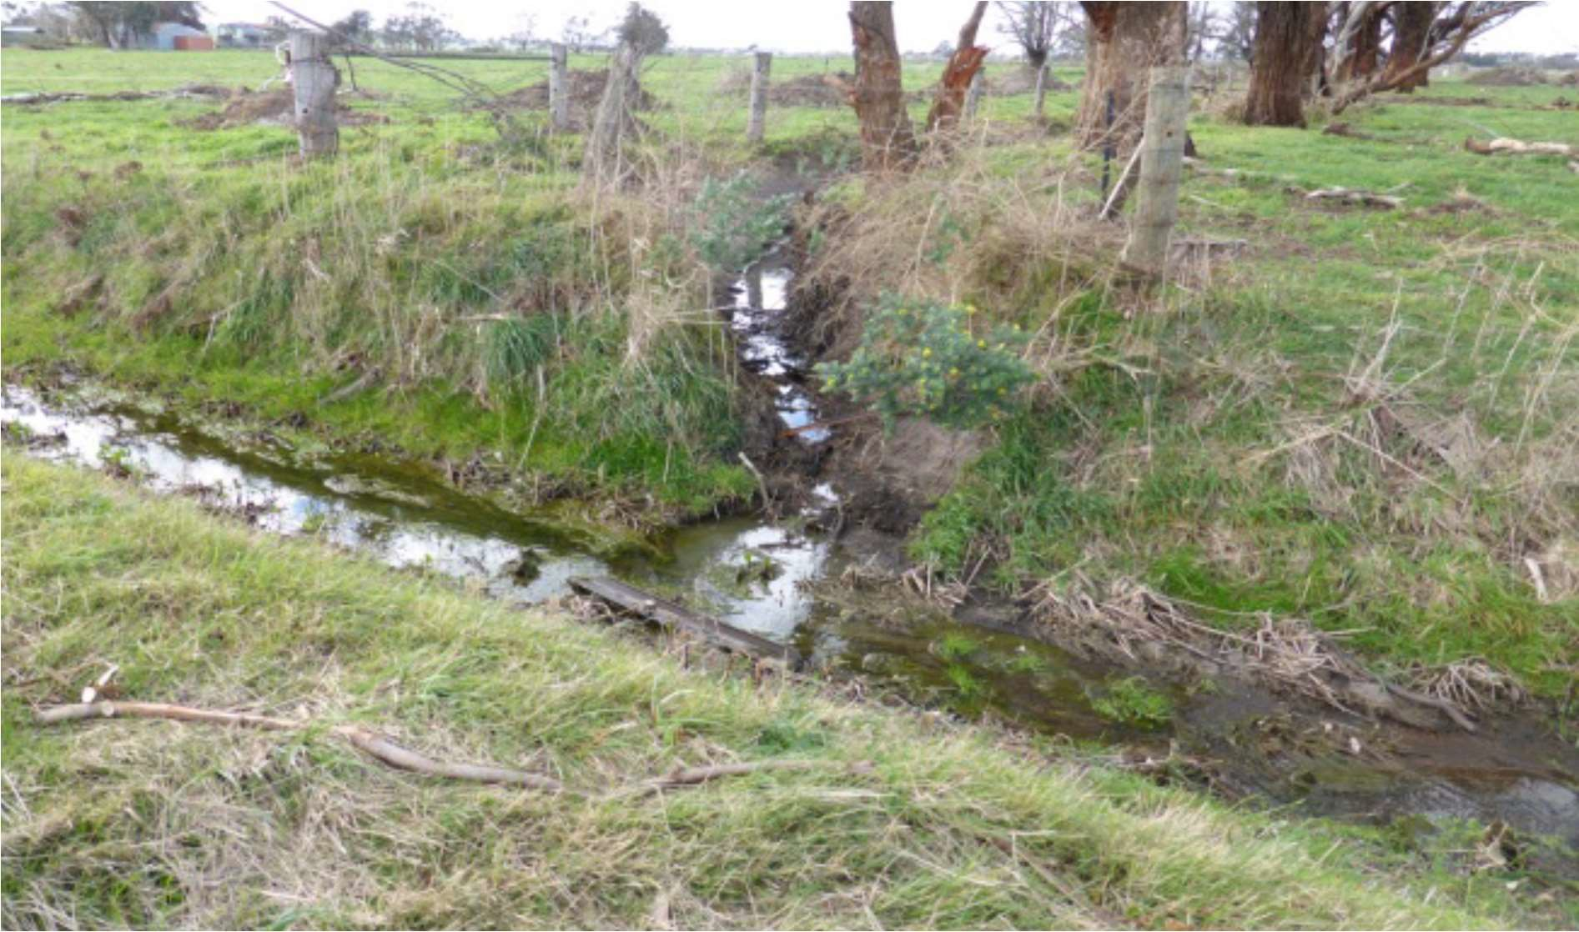

*Figure 5: Private drain intersecting a Precept Drain*

## Landowner responsibilities

We rely on landowner cooperation to improve our service in the District in the following ways.

|  |  |
| --- | --- |
| **Your responsibilities** | |
| **Maintaining your drains** | The management and regular maintenance of private drains is the responsibility of the landowner. As a landowner, you must:   * Ensure that any works carried out on your property do not negatively impact on your neighbours by changing the flow of water across property boundaries. * Contact the relevant authority, usually Melbourne Water or your local council, if you are planning to undertake works on any drains on your property. * Maintain stormwater drainage within your property boundaries and any connections to the District drainage system. * Maintain any culverts, coverings, bridges, or similar structures within your property that cover, or cross stormwater drains, pipes or culverts, unless they are owned by Melbourne Water. |
| **Maintaining safe access** | You are responsible for maintaining safe access for our staff when we need to access your property for drainage purposes. |
| **Notifying us of damages** | You must advise us immediately if there is any damage to our drains or other assets on your property, whether accidental or deliberate. You are responsible for covering any costs associated with repairing damaged Melbourne Water assets on your property.  You must also ensure that water discharged into Melbourne Water drains is not polluted. |
| **Seeking approvals for works** | You must obtain our consent before you undertake building, landscaping or other construction work that is over, or adjacent to, our drains or other assets. This will help us assess if there is likely to be any damage, interference or obstruction of access resulting from the works. Any proposed floodplain filling must be referred to Melbourne Water, for our consent. |
| **Making payments** | You are responsible for paying the Melbourne Water precept rate as part of your retail water account by the date specified unless you have made other payment arrangements through your retail water provider.  If you are experiencing financial hardship, you should contact your retail water provider who will provide you with information about arrangements available to assist you. |
| **Working with our people** | When interacting with our staff, we expect you to treat them with courtesy and respect, and our staff will do the same in return. |
| **Notifying us of issues** | Melbourne Water conducts annual weed spraying involving herbicides. Customers who have concerns relating to the sensitivity of herbicides next to their property are required to contact us to register as a ‘sensitive user.’ |

## Local councils’ responsibility

Melbourne Water works closely with local councils in carrying out its role.

Councils are the local planning authority and responsible for the construction and maintenance of the local drainage system, including urban zones such as within the Koo Wee Rup Township.

Local drainage refers to drainage assets with a catchment area of approximately 200 hectares or less in a rural setting or 60 hectares or less in an urban setting.

Their responsibilities include:

* local road networks
* street and property drainage
* nominating, for the landholder, the legal point of discharge for a site into a council or Melbourne Water drain.

Issues with applications and approvals for all minor local drainage works not located on or impacting a Melbourne Water asset, need to be sought through council.

Councils are also responsible for providing a range of other municipal services.

# Enquiries, information, consultation, and privacy

Ensuring that our customers are aware of our role and can take full advantage of the services we provide.

## How to make an enquiry or find more information

We are focused on listening and responding to our customers’ needs and expectations, delivering on our promises and working together to build awareness and mutual understanding.

There are multiple ways to contact us if you wish to make an enquiry or obtain more information on our work in the District.

### By phone

For general enquiries contact us on 131 722. Overseas callers can reach us on +61 3 9679 7100.

### In writing

You can write to us at: enquiries@melbournewater.com.au or PO Box 4342, Melbourne VIC 3001.

### Online

Let’s Talk - [letstalk.melbournewater.com.au/kwr](http://letstalk.melbournewater.com.au/kwr)

Website - [www.melbournewater.com.au/kooweerup](http://www.melbournewater.com.au/kooweerup)

Facebook - [www.facebook.com/melbournewater](http://www.facebook.com/melbournewater)

Twitter - <https://twitter.com/MelbourneWater>

### Interpreter and TTY services

Melbourne Water provides an interpreter service for people of non-English speaking backgrounds and a service for the hearing impaired.

For translating and interpreting service (TIS), please call 131 450

For hearing or speech impairment services, please call: TTY/voice calls: 133 677

Speak and listen: 1300 555 727

## Consulting with our customers

We are committed to engaging and consulting the community in relation to our operations and works. We are continually evaluating our programs to ensure they are meeting community expectations and provide several avenues, both in-person and on-line, for the community to provide feedback and input.

### Koo Wee Rup – Longwarry Advisory Committee

The Koo Wee Rup – Longwarry Advisory Committee is a representative, ratepayer-based forum made up of members of the Koo Wee Rup – Longwarry Flood Protection District and Melbourne Water.

The Advisory Committee is convened by Melbourne Water and is made up of members of the local community, stakeholder interest groups and representatives from local councils. It meets every four months.

The Advisory Committee is not a decision-making body. It plays an important role in making recommendations to Melbourne Water on a range of matters relevant to ratepayers and residents living in the area. Melbourne Water will consult the Advisory Committee on the following:

* The proposed annual maintenance and renewals plan, including the prioritisation of works.
* The suitability of requests for unscheduled works that exceed the level of service specified in the Koo Wee Rup – Longwarry Flood Protection District Customer Service Charter.
* Other works that Melbourne Water proposes to undertake in the District.

As a group that represents ratepayer interests, customers can contact members of the Advisory Committee for more information on our work in Koo Wee Rup – Longwarry.

Melbourne Water publishes details on the Advisory Committee, including its members and activities, on its website at [www.melbournewater.com.au/kooweerup](http://www.melbournewater.com.au/kooweerup).

### Specific projects

Melbourne Water develops communication and engagement plans for our major projects, including major renewal projects in the District. In designing our work, we commit to:

* Designing engagement programs and communication activities that reach the broadest customer base.
* Communicating openly the action taken to deliver on commitments and how customer and stakeholder feedback has shaped our program activities.
* Designing engagement programs that provide an early opportunity for customers, stakeholders and the community to influence decisions associated with our work.

## Privacy

We only collect and handle personal information to carry out our functions and activities. We are dedicated to protecting the privacy of the personal information we collect from our customers.

The Information Privacy Act 2000 (Vic) requires that we collect and handle personal information in a responsible manner. Melbourne Water’s Privacy Policy (2011) summarises our approach to maintaining information privacy. It also summarises how we will comply with our obligations under the Act.

For further information about our Privacy Policy, please visit our website or contact us at:

Privacy Officer

Melbourne Water

PO Box 4342, Melbourne VIC 3001

Telephone 131 722

Email: [privacy@melbournewater.com.au](mailto:privacy@melbournewater.com.au)

# Requests, complaints, and dispute resolution

Providing opportunities to improve our service through your feedback.

## How to make a request for unplanned works

Requests for unscheduled works must be made by phone - 131 772 or via email to enquiries@melbournewater.com.au OR kooweerup@melbournewater.com.au

Melbourne Water has a capped annual budget derived through the precept rate. Due to these limited funds, Melbourne Water cannot accommodate all requests made for unscheduled works.

The factors we will consider are:

* That the work is consistent with the maintenance framework articulated within Melbourne Water’s respective Asset Management Plans and would have a beneficial impact on the operation of the District’s flood protection system.
* That the work will prevent or reduce the risk of threats and/or failure of Melbourne Water’s asset.

### Notifications

Melbourne Water will provide notification to the requesting landowner within 10 working days of receiving the request.

### Dispute resolution

In the event of protracted negotiations between a requesting landowner and Melbourne Water, Melbourne Water may seek the advice of the Koo Wee Rup – Longwarry Advisory Committee to assist in resolving the request.

## Making a complaint

Melbourne Water seeks to provide excellent service. It is our aim to resolve concerns as soon as possible and to provide a robust and transparent complaints handling process.

Complaints will be accepted verbally to our Customer Service Centre on 131 722 and in writing through a variety of channels such as, email, website feedback submission, social media, and letters.

Complainant’s details will be dealt with in confidence and in accordance with the privacy legislation and any other Acts pertaining to how information should be handled by Melbourne Water. Details of the complainant will only be known by those directly concerned in resolution.

### Reviewing complaints and disputes

Customers can request an internal review of our response if they are not satisfied with the response provided. A senior representative of the organisation (a direct report to a General Manager) will review the complaint, complaint handling and response provided to the complainant.

### Seeking external resolution of disputes

Where resolution of the complaint cannot be agreed, our customers can seek external resolution.

The **Dispute Settlement Centre of Victoria (DSCV)** provides a service that can help you resolve common neighbourhood disputes involving fences, trees, animals, noise, and drainage issues. This free and confidential service is funded by the Victorian Government.

To contact the Dispute Settlement Centre of Victoria (DSCV), call 1800 658 528 or visit the DSCV website: [www.reachingagreement.disputes.vic.gov.au](http://www.reachingagreement.disputes.vic.gov.au/) for more information.

If you are unable to resolve your dispute via the DSCV, you may contact the **Energy and Water Ombudsman Victoria (EWOV),** an industry funded free to the public complaint resolution service. EWOV has the power to investigate and resolve disputes between Victorian electricity, gas and water customers and their service providers.

EWOV contact details:

Freecall: 1800 500 509

Freefax: 1800 500 549

Interpreter: 131 450

NRS: 133 677

Email: [ewovinfo@ewov.com.au](mailto:ewovinfo@ewov.com.au)

Postal address: Energy and Water Ombudsman (Victoria) Ltd, GPO Box 469 Melbourne 3001

### Response times

Melbourne Water will respond to your enquiries as promptly as possible. We aim to meet the following response times.

|  |  |
| --- | --- |
| Channel | Response times |
| **Written and online correspondence** | Within 10 working days of receipt |
| **Social media enquiries** | Within 3 working days of receipt |
| **Verbal enquiries** | Within 3 working days of being placed |

If we need additional time to resolve your enquiry, we will contact you to keep you informed of the additional time required and the reasons for the delay.

# Reporting on our performance

Providing information to our customers on how we are performing.

## Assessing our performance

Melbourne Water’s Customer Commitment sets out several targets for organisational performance in how we work with our customers.

Importantly, we want customer and stakeholder feedback to inform our activities and to maintain at least 70 per cent satisfaction rating with our drainage and waterways services through our Customer Satisfaction survey (CSAT).

Melbourne Water will track its performance in customer service in the District in two key ways:

* Regularly at the conclusion of interactions with individual precept ratepayers.
* Through an independently conducted survey of randomly selected precept ratepayers.

## Corporate level reporting

Melbourne Water’s performance in providing flood protection and drainage services to our precept ratepayers is reported each year in our Annual Report.

<https://www.melbournewater.com.au/about/what-we-do/annual-report>

## Specific reporting for precept ratepayers

Melbourne Water is committed to providing information to its precept ratepayers on its performance.

### Proposed annual works program

The works program is developed in collaboration with the Koo Wee Rup - Longwarry Advisory Committee and reported on at each Advisory Committee meeting.

Works being delivered at any time can be viewed on the Melbourne Water website. <https://www.melbournewater.com.au/building-and-works/whats-happening-near-me>

# Definitions

|  |  |
| --- | --- |
| Term | Definition |
| **Annual Exceedance Probability (AEP)** | AEP is the likelihood of a flood of a given size happening in any one year. AEP is usually expressed as a percentage. A measure of the rarity of a rainfall event. |
| **Average Reoccurrence Interval (ARI)** | ARI is the estimated number of years between floods of a given size which is expressed in years. ARI is another way of expressing the likelihood of occurrence of a flood event (see AEP). A measure of the rarity of a rainfall event. |
| **Carrier drain** | A drain that originates outside the precept area, carrying water through the area and taking water from the precept drains. |
| **Complaint** | A written or verbal expression of dissatisfaction about an action, or proposed action, or a failure to act by Melbourne Water, its employees, or contractors. This includes the failure of Melbourne Water to observe its published policies, practices, or procedures. |
| **Customer** | A customer is any individual or group who receives service(s) from us. Our customers include the metropolitan retail water businesses, other water authorities, land developers and businesses that divert river water. The 1.8 million households who receive waterways and drainage services are also our customers. |
| **EWOV** | Energy and Water Ombudsman Victoria an alternative dispute resolution scheme. It is not a government body, but a not-for-profit company. It receives, investigates, and resolves customer complaints about electricity, natural gas, bottled gas (LPG) and water companies operating in Victoria. |
| **Floodplain** | A floodplain is an area of low-lying land adjacent to a waterway. It is normally dry but is subject to flooding during periods of high rainfall. |
| **Personal information** | Information or an opinion (including information or an opinion forming part of a database), that is recorded in any form and whether true or not, about an individual whose identity is apparent, or can be reasonably ascertained, from the information or opinion but does not include personal health information. |
| **Precept drain** | A drain that originates within the flood protection district and drains the local area. |
| **Stormwater** | Rainfall that runs off roofs, roads, and other surfaces where it flows into gutters, streams, rivers, and creeks, and eventually into the bays. This water can carry contaminants such as plastic bags, detergents, nutrients, and heavy metals. |
| **Victorian Ombudsman** | The Victorian Ombudsman is an independent officer for the Victorian Parliament who investigates complaints about state government departments, most statutory authorities, and local government. |

# Operating context

Melbourne Water delivers its services in the District under a legislative, policy and strategy framework. This framework covers the following:

## Our regulation

|  |  |
| --- | --- |
| **The Water Act 1989** | Specifies the functions that Melbourne Water must carry out for drainage systems and floodplain management. |
| **Statement of Obligations 2012** | Sets out Melbourne Water’s customer and community engagement obligations, and obligations to develop strategies that set out the responsibilities, goals, levels of service and programs of work for waterway management, flood management and drainage. |

## Our Waterways program

|  |  |
| --- | --- |
| **Melbourne Water's Flood Management Strategy** | Defines five flood management objectives and outlines actions to achieve these and guide priorities and expenditure by Melbourne Water. |
| **Melbourne Water’s Healthy Waterways Strategy** | Articulates the high-level strategic direction and management approaches for Melbourne Water in managing stormwater in rural and urban areas to deliver multiple community outcomes. |